**PROCESS MANAGEMENT**

**What is a Process?**

* An instance of a program is called a Process.
* Any command that you give to your Linux machine starts a new process.

**Types of Processes in Linux?**

**Foreground Processes:**

* They run on the screen and need input from the user.
* For example: Office Programs.

**Background Processes:**

* They run in the background and usually do not need user input.
* For example: Antivirus.

TO LIST THE PROCESSES:

* top

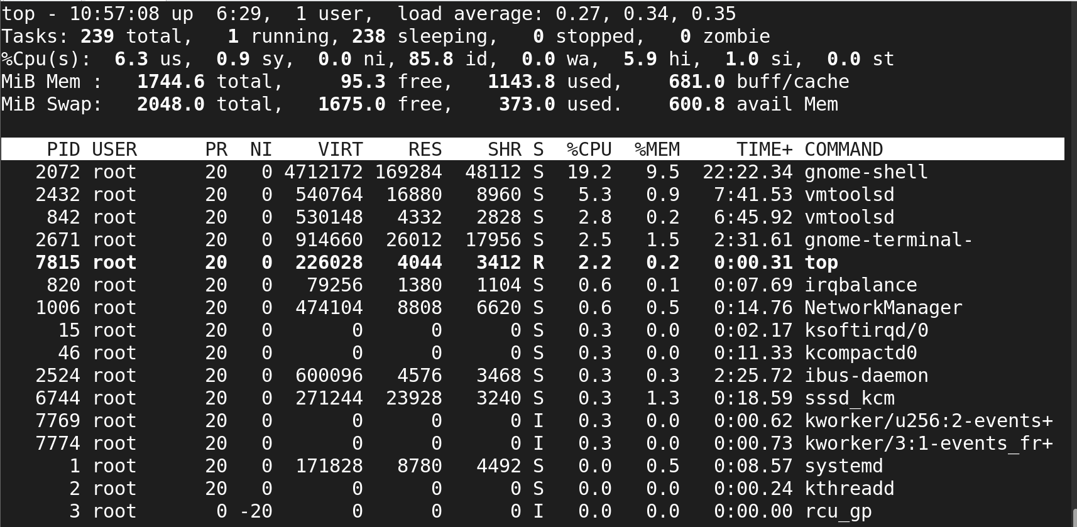

* **ps -­efa**

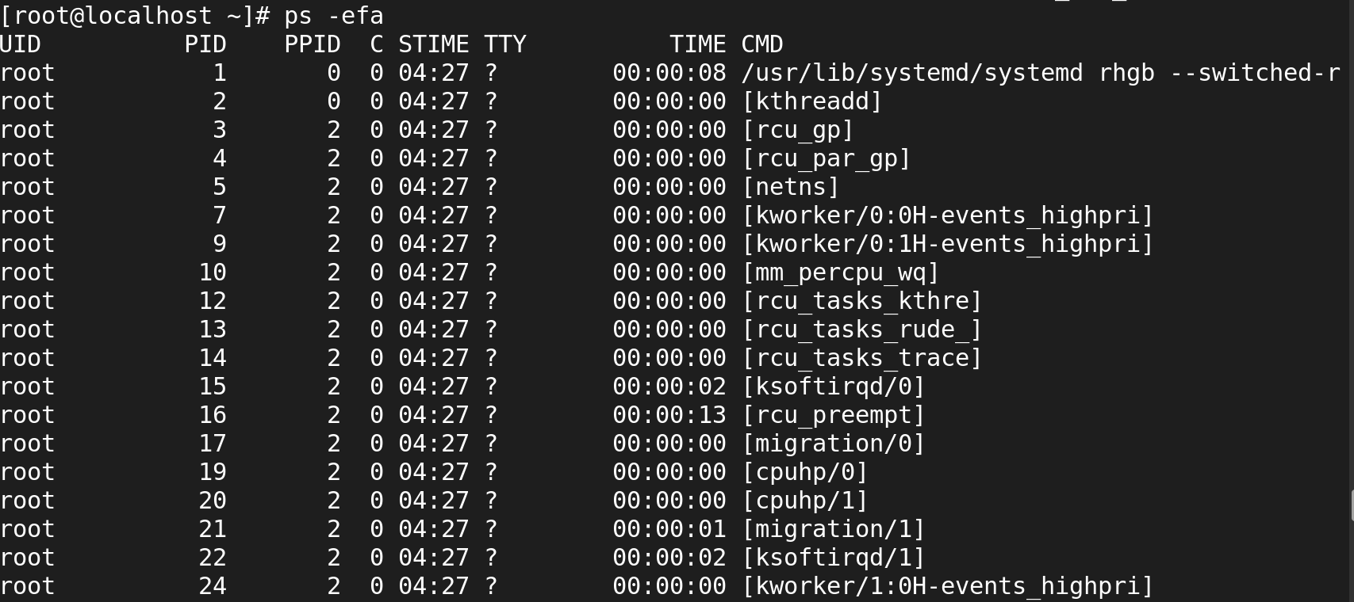

* **ps -ef**

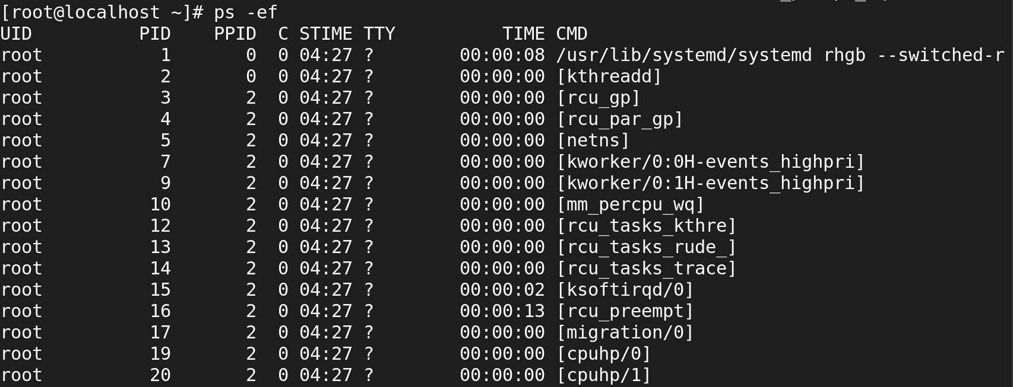

* **ps -aux|less**

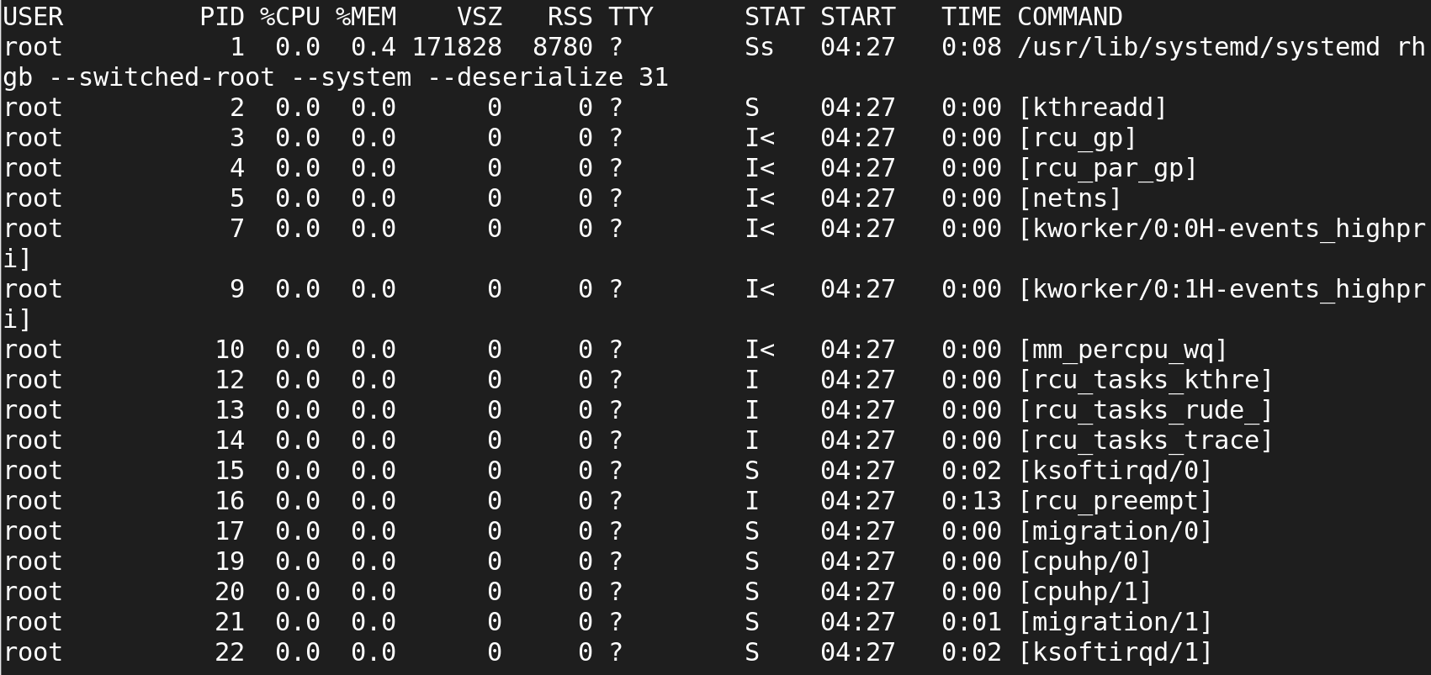

**TO LIST A SPECIFIC USER'S PROCESSES**

* **ps -­u username**

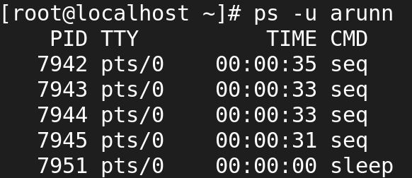

**Foreground Processes:**

* **fg %2**

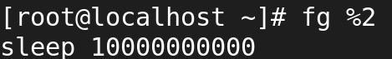

**Background Processes:**

* **bg %2**

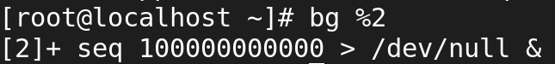

* **jobs**

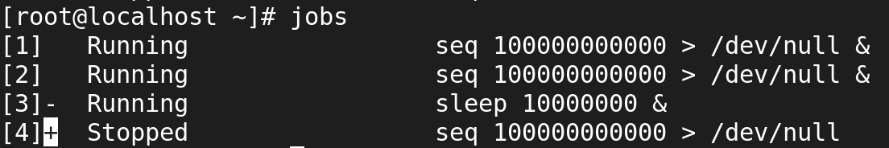

# PARENT PROCESS:

* In Linux all the processes have a parent process. When the user creates a process in that case the kernel process becomes the parent of that process.
* Every Linux process has two ID , the Process ID (pid) and the Parent process ID (ppid).
* **ps -f**

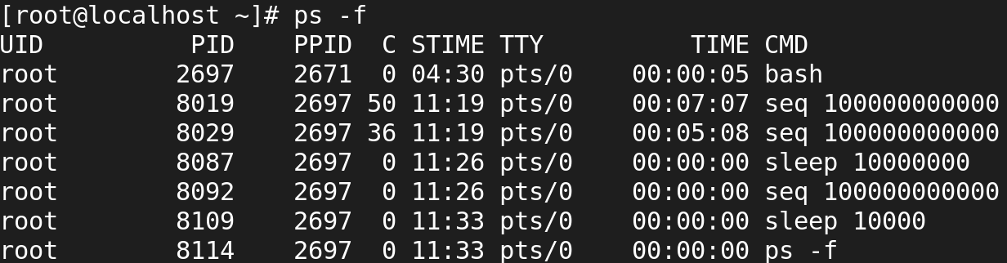

* **pidof sleep**

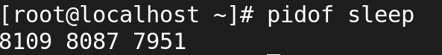

* **pstree 8092**

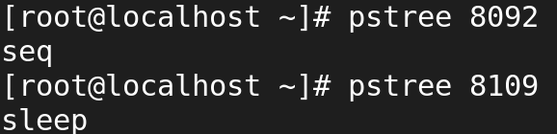

**Child Processes:**

* The processes which get created by another process its parent process known as child process.
* In our above example, the sleep process with PID 1971 is a child process of the bash process with PID 1589.

# DAEMON PROCESS:

* The system related background running processes are called Daemon Processes.
* When you see a process running with a ? mark in sixth column (TTY field), that's a daemon process.
* **ps -ef**

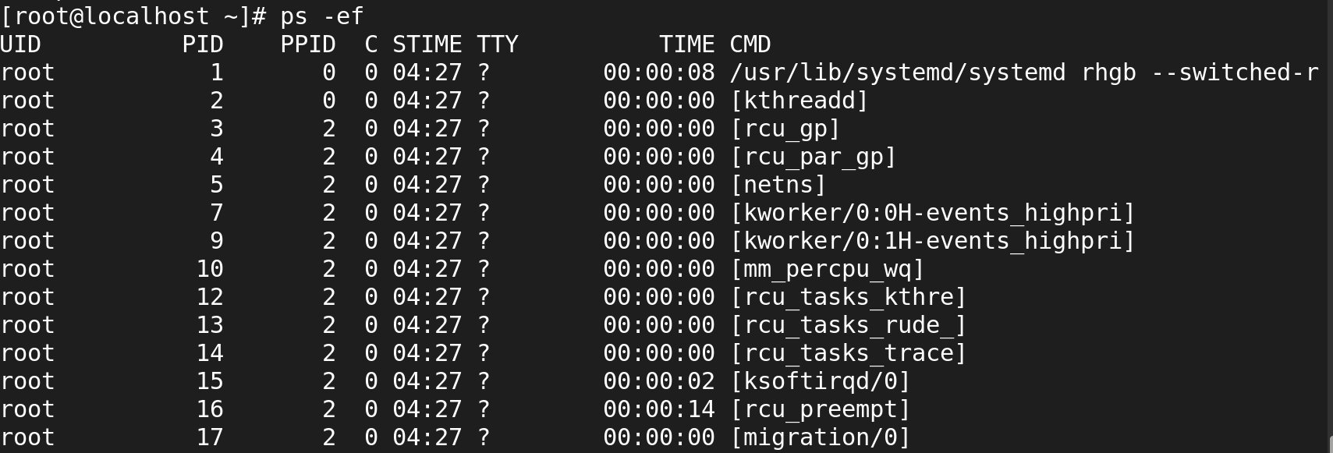

# Zombie processes:

* At times there are processes which are already dead but still shows up in process list are called Zombie processes.
* These processes can be found while doing ps listing, the process with a Z state are zombie processes.
* They don't consume any CPU resources.

# THE PROCESS STATUS CAN BE ANY OF THE FOLLOWING:

* R 🡪 Running process which is executed on CPU.
* S 🡪 Sleeping or waiting process. This process is in waiting stage for a signal.
* D 🡪 Uninterruptable. This process is in sleeping process which will not respond to a signal.
* T 🡪 Stopped process or suspended process. This process can be continued by another signal to return to running process.
* Z 🡪 Zombie process. This is a child process sending its parent process an exit signal.
* TASK_INTERRUPTABLE (S) 🡪 process is sleeping but can be woken up(interrupted)
* TASK_UNINTERRUPTABLE(D) 🡪 process is sleeping but cannot be woken up (uninterrupted)
* **pkill sleep**

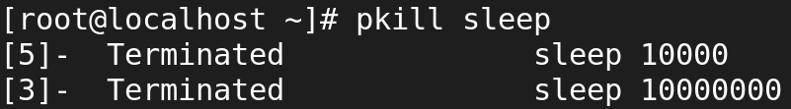

* **killall sleep**

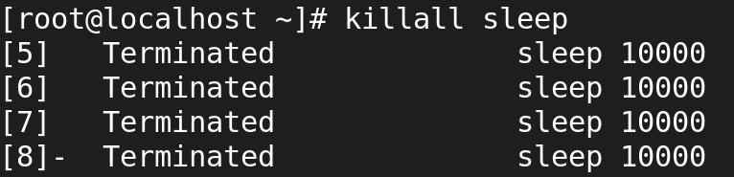

# SCHEDULING PRIORITIES:

* Every process has scheduling priorities.
* The value which is assigned for scheduling the priorities is called "NICE VALUE"
* Nice value range is -­20 to 19
* The default nice value of a process is 0.
* High nice value process means low CPU usage. (19)
* Low nice value means High CPU usage. (-20)
* The root user can increase or decrease the priorities of a process.
* The normal user can only increase the priority of a process.

TO SCHEDULE PRIORITIES**:**

**For running process**

* renice nicevalue PID
* renice ­3 15232



**For new process**

* nice ­n nicevalue command
* nice -n -20 seq 100000000000000000000 > /dev/null

